**Subject: PRF192- PFC**

**Đặng Hoàng Nguyên – SE171946**

**Workshop 01**

**Objectives:**

(1) Reviewing for number systems

(2) Exploring memory of a C program

**Recommendations**

Part 1: Students do exercises using notebooks

Part 2: Students develop programs, run them, write down their memory structure to notebooks.

**Part 1: Number systems**

**Exercise 1 (2 marks): Convert decimal numbers to binary ones**

|  |  |  |  |  |  |
| --- | --- | --- | --- | --- | --- |
| Decimal | 4-bit  Binary | Decimal | 8-bit  Binary | Decimal | 16-bit Binary |
| 9 | 1001 | 7 | 0000 1111 | 255 | 0000 0000 1111 1111 |
| 7 | 0111 | 34 | 0010 0010 | 192 | 0000 0000 1100 0000 |
| 2 | 0010 | 125 | 0111 1101 | 188 | 0000 0000 1011 1100 |
| 15 | 1111 | 157 | 0001 1101 | 312 | 0000 0001 0011 1000 |
| 12 | 1100 | 162 | 1010 0010 | 517 | 0000 0010 0000 0101 |
| 11 | 1011 | 37 | 0010 0101 | 264 | 0000 0001 0000 1000 |
| 6 | 0110 | 66 | 0100 0010 | 543 | 0000 0010 0001 1111 |
| 5 | 0101 | 77 | 01001101 | 819 | 0000 0011 0011 0011 |
| 8 | 1000 | 88 | 0101 1000 | 1027 | 0000 0100 0000 0011 |
| 13 | 1101 | 99 | 0110 0011 | 2055 | 0000 1000 0000 0111 |
| 14 | 1110 | 109 | 0110 1101 | 63 | 0000 0000 0011 1111 |

**Exercise 2(2 marks): Convert decimal numbers to binary and hexadecimal ones**

|  |  |  |  |  |  |
| --- | --- | --- | --- | --- | --- |
| Decimal | Binary | Hexa | Decimal | Binary | Hexa |
| 9 | 1001 | 9 | 255 | 1111 1111 | FF |
| 127 | 0111 1111 | 7F | 192 | 1100 0000 | C0 |
| 125 | 0111 1101 | 7D | 188 | 1011 1100 | BC |
| 157 | 0001 1101 | 9D | 312 | 0001 0011 1000 | 138 |
| 162 | 1010 0010 | A2 | 517 | 0010 0000 0101 | 205 |
| 37 | 0010 0101 | 25 | 264 | 0001 0000 1000 | 108 |
| 66 | 0100 0010 | 42 | 543 | 0010 0001 1111 | 21F |
| 77 | 0100 1101 | 4D | 819 | 0011 0011 0011 | 333 |
| 88 | 0101 1000 | 58 | 1027 | 0100 0000 0011 | 403 |
| 99 | 0110 0011 | 63 | 2055 | 1000 0000 0111 | 807 |
| 109 | 0110 1101 | 6D | 63 | 0011 1111 | 3F |

**Exercise 3(2 marks): Compute**

(b: binary, q: octal, h: hexadecimal)

3245q + 247q = 3514q = 110110111010b

1A7Bh + 26FE7h = 28A63h = 101100101111b

1101101101b - 10110111b =1010110110b

3654q – 337q = 6CDq = 11011001101b

3AB7h – 1FAh = 38BDh = 11100010111101b

36Ah – 576q = 1ECh h = 111101100b

64AEh – 1001101b= 62141q

  101101111 b

+ 100111011 b

  110110001 b

  110001101 b = 10111101000b

1011010b* 1011b = 1111011110b

1101000b + 2AB h + 345 q =3F8hh =1770q

3AFh / 1Ch =100001 b =33 d

3ACh – 562q =1000111010b =570d

3FFA h / 327q =1001100 b =76 d

**Exercise 4 (2 marks)**

Show binary formats of 1-byte unsigned numbers:

251 = 1111 1011b

163 = 1010 0011b

117 = 0111 0101b

Show binary formats of 2-byte unsigned numbers:

551 = 0000 0010 0010 0111b

160 = 0000 0000 1010 0000b

443= 0000 0001 1011 1011b

Show binary formats of 1-byte signed numbers:

-51 = 11001101b

-163 = 0101 1101b

-117 = 1000 1011b

320 = 0001 0100 0000b

Show the decimal values of 1-byte unsigned representations:

01100011b = 99d

10001111b = 143d

11001010b =202d

01001100b =76d

**Part 2: Explore memory structure of programs**

**Sample**

**Complete the code of following program then draw it’s memory structure (2 marks)**

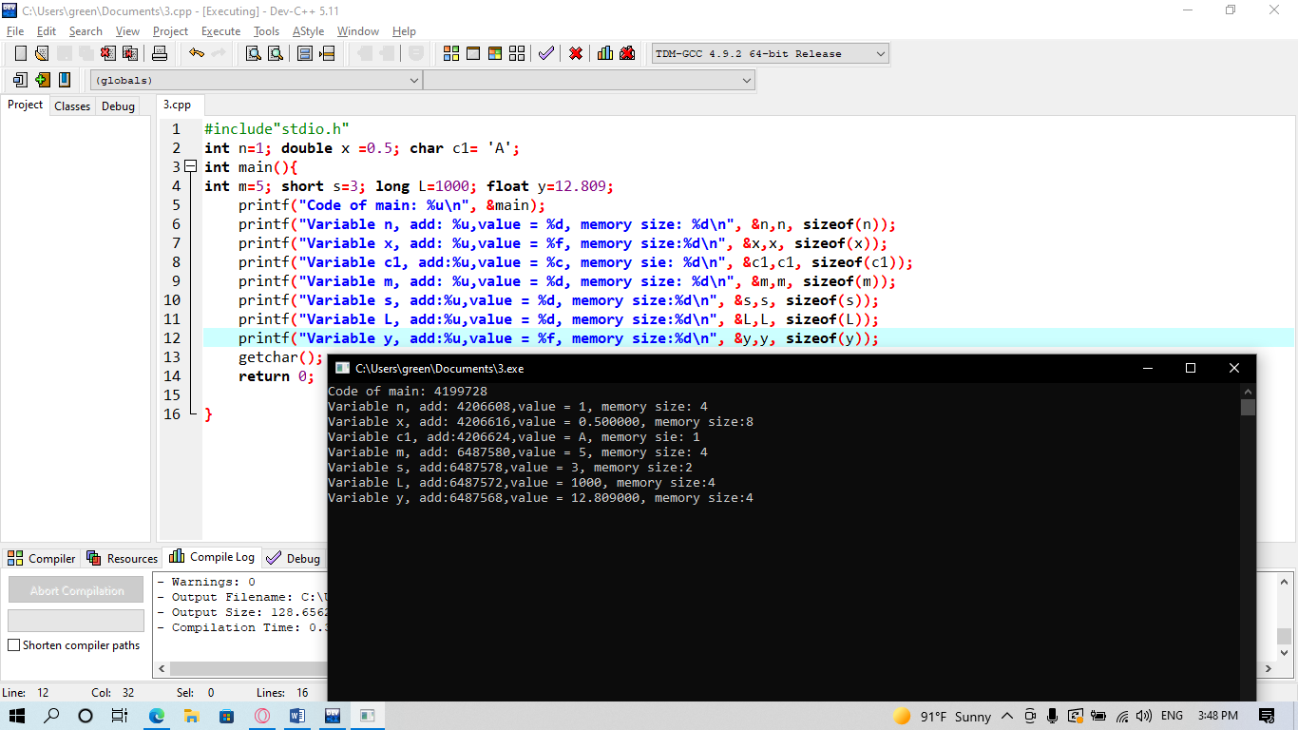

1

**n: 4206608**

**x: 4206616**

**c1: 4206624**

**m: 6487580**

**s: 6487578**

**L: 6487572**

**y: 6487568**

12.809

1000

5

3

A

0.5